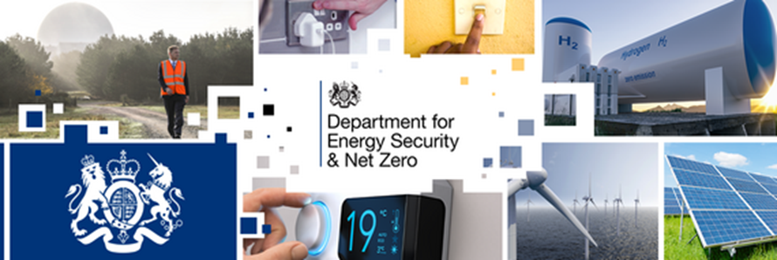

Welcome to the latest bulletin from the Department for Energy Security and Net Zero.
Last chance to apply for help with energy bills
Customers with pre-payment meters are eligible for vouchers under the Energy Bill Support Scheme to help with their bills. Vouchers must be claimed by 30 June, and we are working to ensure that all of those who are eligible receive the support to which they are entitled.
We have put together a toolkit containing posters and digital assets to remind people to apply before the deadline and would be grateful if you could share these on your social channels or any public facing displays you may have.
We will also be mounting a big push on social media on 31 May and would appreciate your support to help ensure the message reaches the widest audience.

Ofgem announces new energy price cap
Ofgem has announced that the energy price cap will be set at an annual level of £2,074 from 1 July. This is a reduction of £426 and reflects recent falls in wholesale energy prices.
Customers need take no action following this morning’s announcement.
The Secretary of State tweeted about the updated price cap and we have published an explainer video, and we would be grateful if you could help to amplify these on your channels.
In other news
- Minister Stuart spoke at the Innovation Zero conference to update on the government's commitment to Net Zero and the progress made by the Net Zero Innovation Portfolio.
- The first meeting of the new Solar Taskforce took place this week, and discussed how to encourage more businesses and households to install solar panels to help reduce bills alongside plans to increase the solar workforce and secure supply chains as part of the government’s target to increase solar capacity by nearly fivefold to 70GW by 2035.
- New figures published today show that the UK has gone a full year without importing any Russian gas. At the same time, UK gas exports to Europe tripled over the same period and renewables generated a record 46.2% of UK electricity from major power producers over the past 3 months. This is up from just 3.5% for the same period in 2010.
Please follow our social channels Twitter | LinkedIn | Instagram
If you want to get in touch, email us at externalaffairs@energysecurity.gov.uk

